Case Study

1. Creating bucket

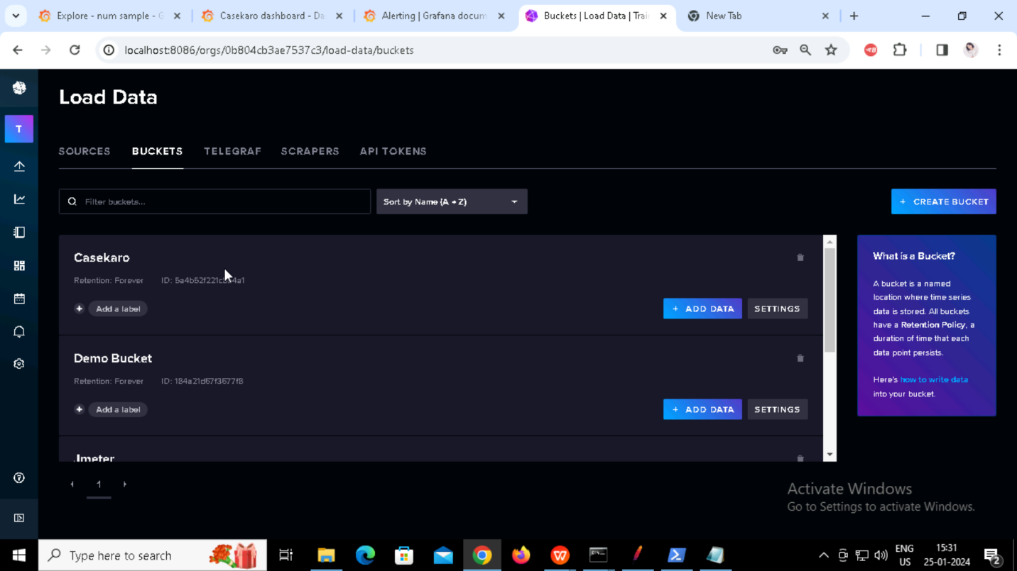

1. Creating backend listener for Casekaro http request

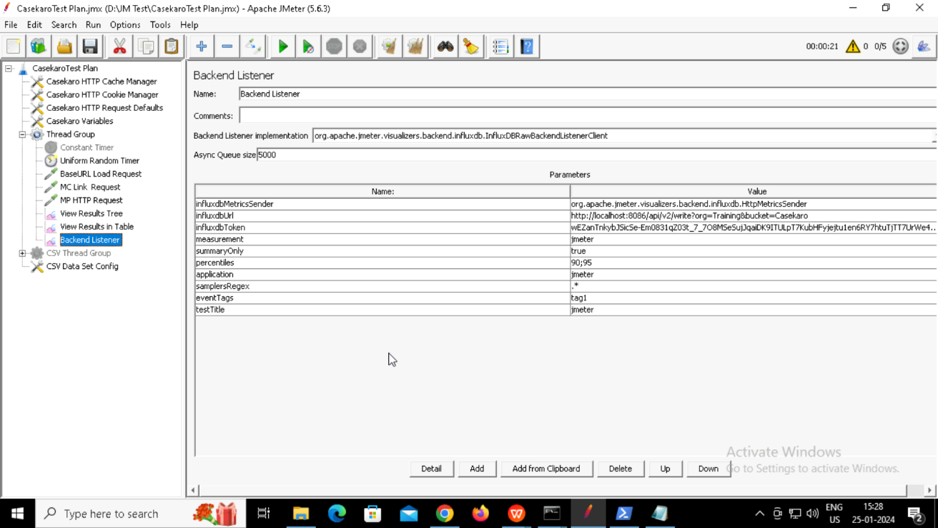

3.Creating different panels

1. Creating Alerts

